# DIY flashlight for emergency lighting

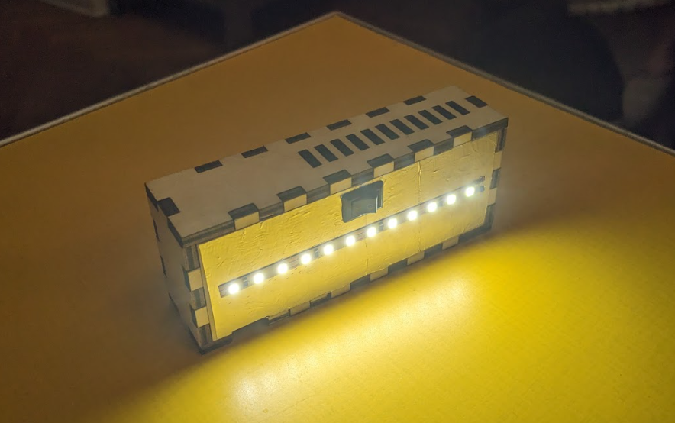

This is a small flashlight on one 18650 battery with a bright LED strip that you can make yourself.

The flashlight can be attached to metal structures using a magnet.

The flashlight is enough to illuminate one small room.

The time of continuous operation is more than 20 hours (if you use a new battery).

The flashlight can be recharged from a mobile phone charger via a type C cable.

## Files

Case file for cutting on a laser cutter - **light-v5_hacklab-tolocar_x1.dxf**

If you plan to make several flashlights - use the file on which 4 cases for flashlights are arranged - **light-v5_hacklab-tolocar_x4_300x400.dxf**

or 6 cases for flashlights - **light-v5_hacklab-tolocar_x6_380x580.dxf**

## How to make a flashlight for emergency lighting with your own hands

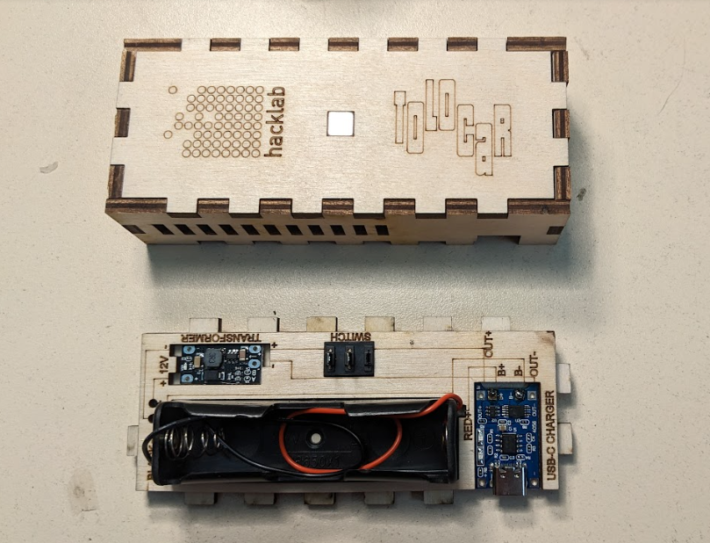

This is a detailed step-by-step guide for beginners. If you are not soldering components for the first time, you can skip it and focus on the diagram engraved on the inside of the flashlight.

### 

### Step 1

Download dxf files for laser cutting.

Red lines must be cut through, black lines must be engraved on wood.

Cut out the case parts from plywood 4 mm thick.

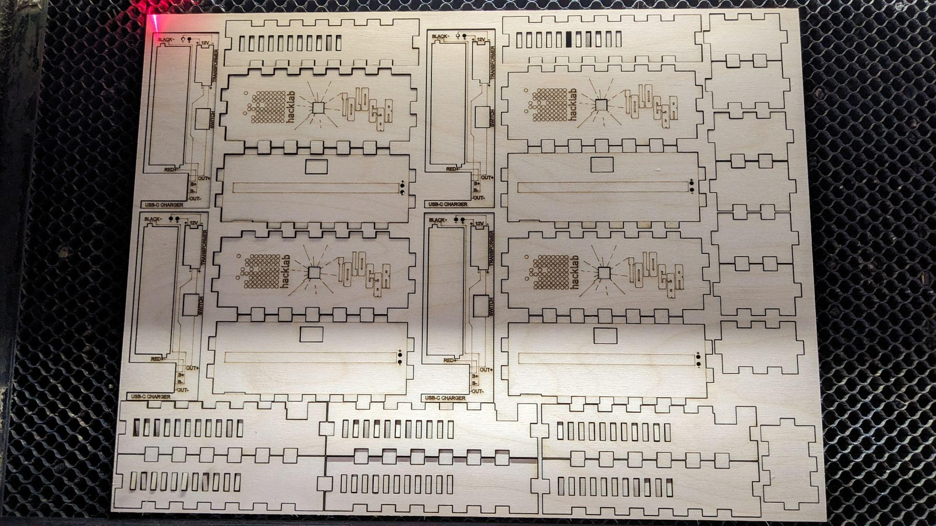

**If you don't have a laser cutter, you can:**

a) find a public workshop (hackerspace, makerspace, fablab) in your city and use their equipment.

The list of workshops in Ukraine can be found here - <https://makerhub.org/all-makerspaces-ukraine/>

b) order cutting on a laser cutter from private companies

c) use any existing plastic or wooden box that is suitable in size (for example, from under candy), making a hole in it for the type C connector (so that the flashlight can be charged) for the switch and two small holes for wires.

### Step 2

### 

Cut a strip of aluminum tape 10 by 4 cm. Stick it on the back side of part A (where the strip is engraved).

This tape will serve as a heatsink so that the diode tape does not overheat.

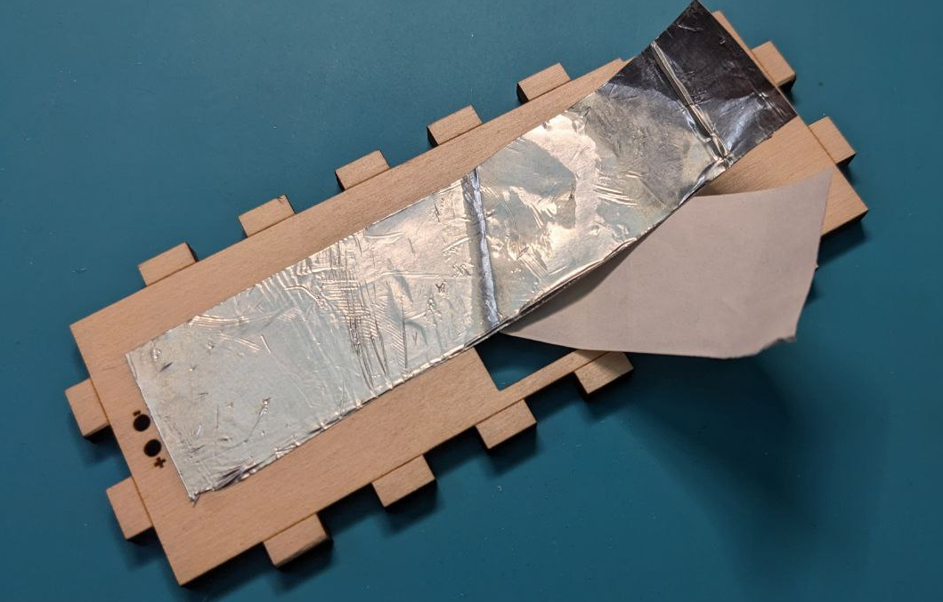

Cut the tape in those places where there are holes in the wooden part, if you accidentally glued them (this can be done with a stationery knife or scissors).

### Step 3

Glue together parts А and Б with glue.

The holes on both parts (2 round holes for the wires and 1 square for the switch) must match.

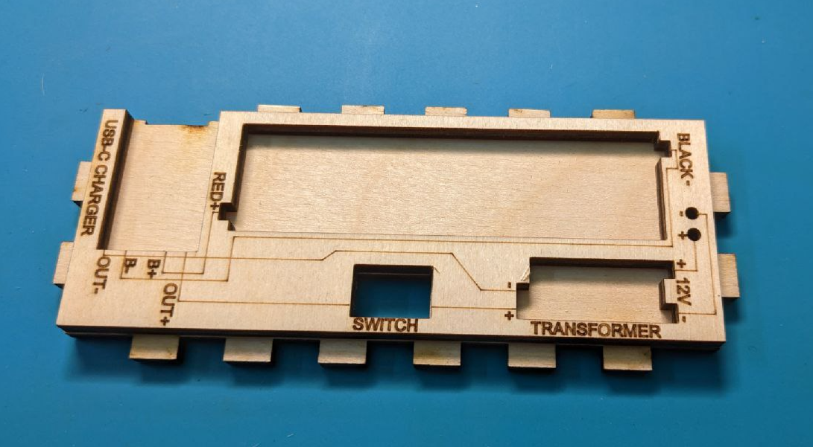

### Step 4

Insert the magnet into the part В, having previously smeared the sides of the magnet with glue, so that it is securely fixed in the hole.

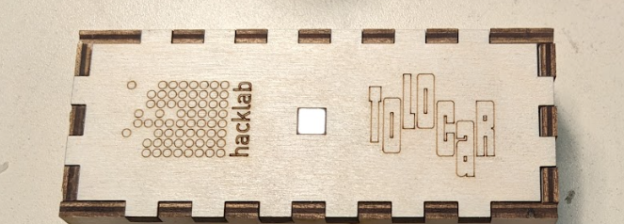

### Step 5

Connect the wooden parts В, Г, Ґ, Д and Є as a constructor.

Please note that the hole for part Г must be in the same place where the bms with type C output will be.

The parts do not need to be glued to each other, they should hold tightly together by themselves.

If suddenly, because of the cut settings, the parts do not hold together - you can glue them at the end, when you make sure that everything works and is in the right place.

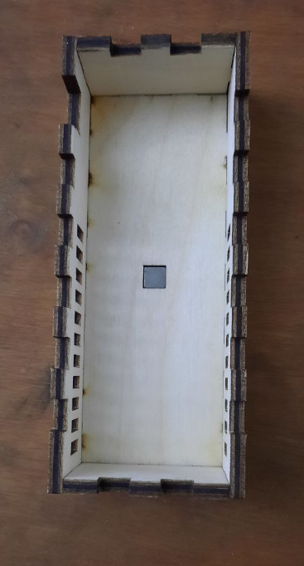

### Step 6

Take the battery holder and BMS module for charging with Type C output. Place them in the special holes on the parts АБ.

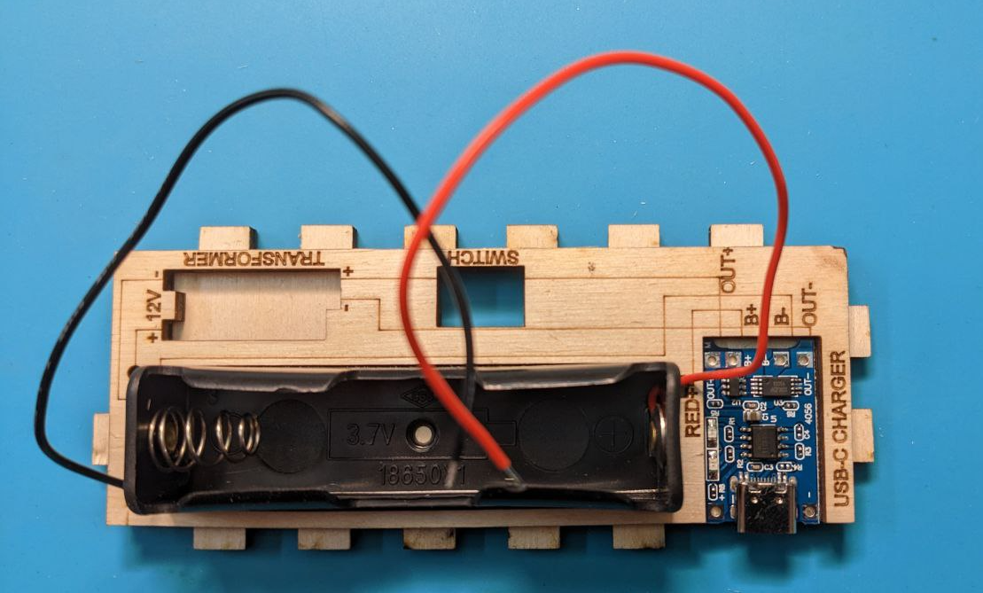

The black wire of the battery holder must be soldered to point B- on the BMS module. Red wire - to point B+. Cut the red wire to the desired length and solder both wires.

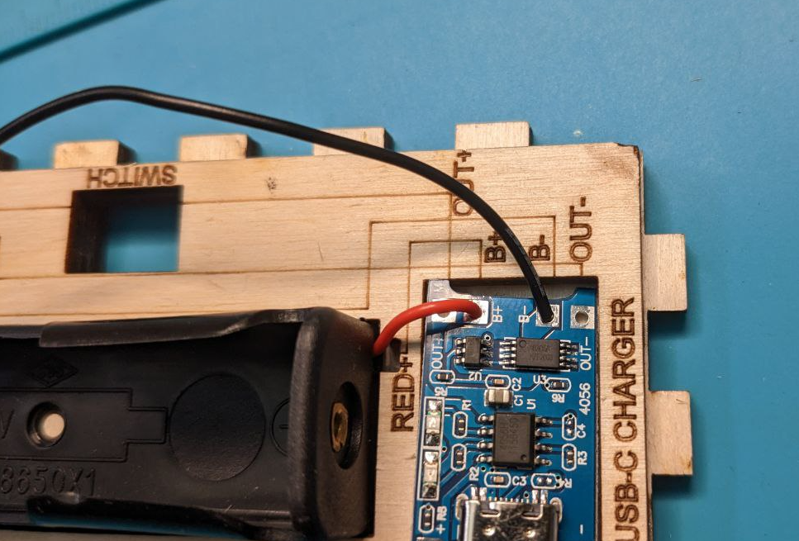

### Step 7

Insert the switch into the hole labeled SWITCH on the housing part A, so that the button is on the outside of the housing, and the legs of the switch are on the inside.

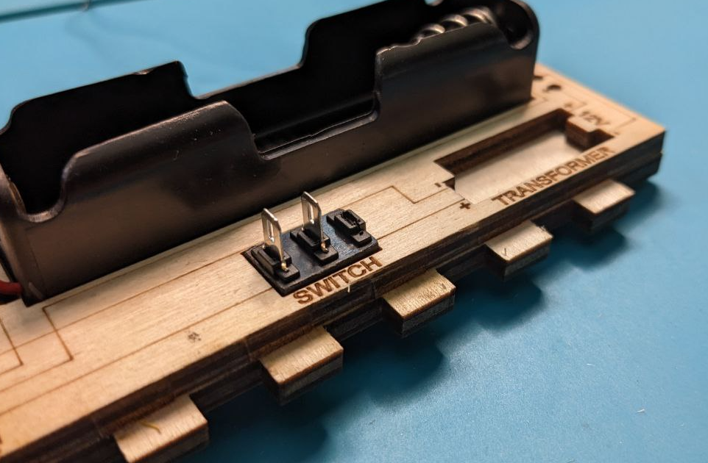

### Step 8

Measure and cut 1 piece of red wire from the OUT+ point of the BMS Type C charging module to the nearest switch pin. Strip the wire and solder it.

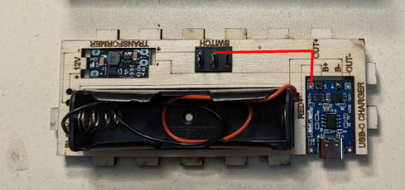

### Step 9

Take the DC-DC Mini Step Up Module, it should be in the slot labeled Transformer.

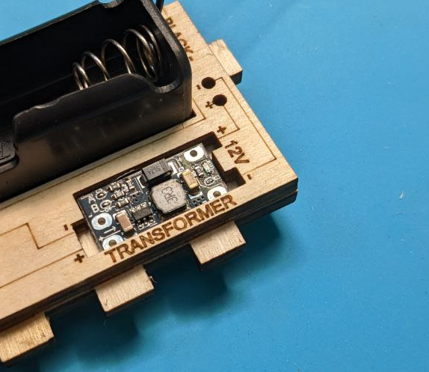

Note that there is a small arrow on the module. Position the module so that the arrow points away from the switch.

Measure and cut 1 piece of red wire from the second leg of the switch to the nearest + point (near the arrow) on the step-up module.

Strip the wire and solder it.

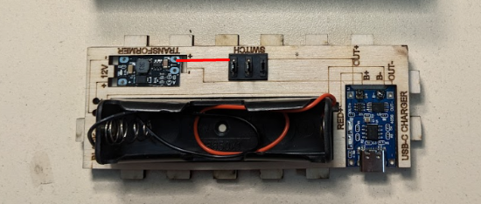

### Step 10

Measure and cut 1 piece of black wire from the OUT- point of the BMS Type C charging module to the nearest - point (near the arrow) on the step-up module. Strip the wire and solder it.

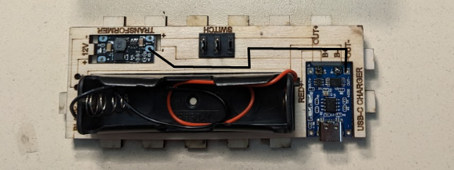

### Step 11

Measure and cut 1 piece of red wire from the free + point on the step-up module to the + mark on the back of this part. The wire must pass through the round hole. Solder one end of the wire to the free point + on the step-up module.

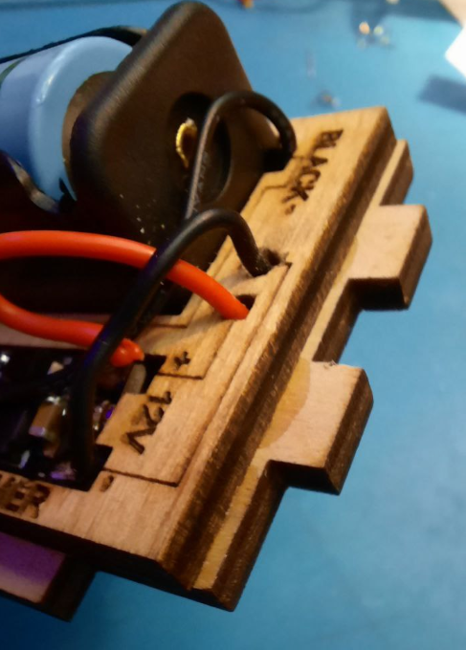

Cut 10 cm of LED strip. Solder the other end of the red wire to the + point on the led strip.

Repeat this with the black wire, soldering it, according to the free point - on the step-up module and to the point - on the LED strip.

Glue the led strip in the middle of the part to the aluminum tape.

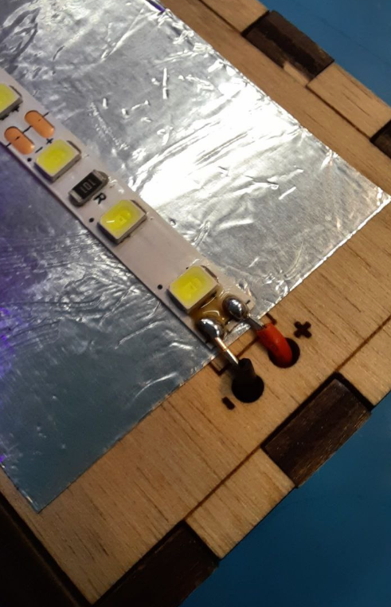

### Step 12

Insert the 18650 rechargeable battery into the battery holder. Check if the flashlight is working.

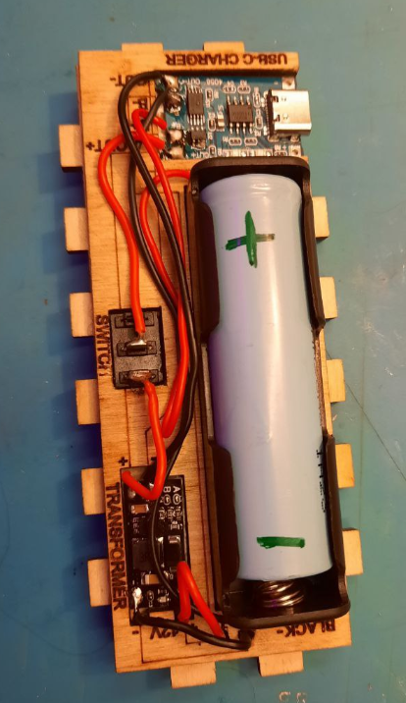

If everything works, stick the kapton tape on the LED strip so that the kapton tape completely covers the ends of the wires and the soldering points.

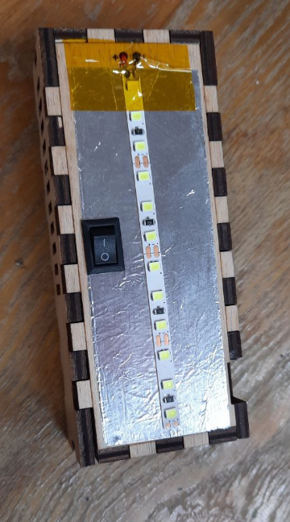

Take pieces of double-sided tape and fix the BMS module, step-up module and battery holder in the corresponding holes.

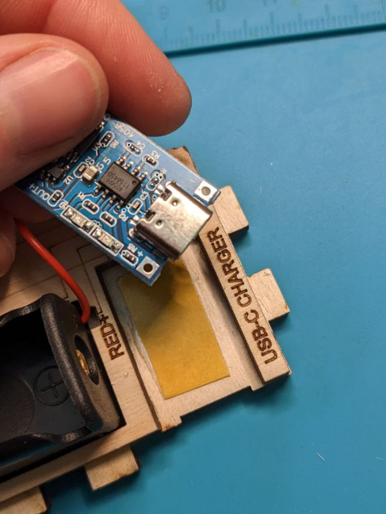

Connect all the parts of the case together. If any part is not held firmly enough, fix it with glue.

Don't forget to charge your flashlight from time to time.